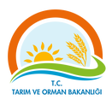 | Republic of Turkey  The Ministry of Agriculture and Forestry  Veterinary Control Central Research Institute  Genetics Laboratory  Ankara – TURKEY  Phone: +90 312 326 00 90 Fax: +90 312 321 17 55  E-mail: etlik.vkmae@tarim.gov.tr  Web: http://vetkontrol.tarim.gov.tr/merkez  DNA Parentage Validation Certificate | 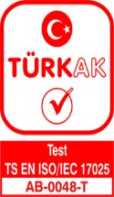  AB-0048-T  00000  00.00.0000
DNA No :
Test Date :
Horse Name :
Date of Birth :
Sex :
Breed :
Chip No :
Source :

Sire Name : Dam Name :
Date of Birth : Date of Birth :
DNA No : DNA No :

*
AHT4 | AHT5 | ASB2 | ASB17 | ASB23 | CA425 | HMS1 | HMS2 | HMS3 | HMS6

HMS7 | HTG4 | HTG6 | HTG7 | HTG10 | LEX3 | VHL20

Veterinary Control Central Research Institute is accredited by TÜRKAK under registration number [AB-0048-T] for [TS EN 17025] as test laboratory”
The Turkish Accreditation Agency (TURKAK) is signatory to the multilateral agreements of the European co-operation for the Accreditation (EA) and of the International Laboratory Accreditation (ILAC) for the Mutual recognition of test reports.
Date :
Approved by :

Signature :
*Atlarda ebeveyn doğrulaması için en az 12 adet bakılması zorunlu lokus bulunmaktadır.

